Senior Software Project – Report 1

# Team Members

|  |  |  |
| --- | --- | --- |
| **Team 1** | **Email** | **Phone** |
| Bonnie Brent | [bbrent@trinity.edu](mailto:bbrent@trinity.edu) | (713) 501-6186 |
| Danny Saltus | [dsaltus@trinity.edu](mailto:dsaltus@trinity.edu) | (512) 569-3916 |
| **James Seales\*\*** | [jseales@trinity.edu](mailto:jseales@trinity.edu) | (210) 215-7098 |
| William Shepherd | [wshepher@trinity.edu](mailto:wshepher@trinity.edu) | (832) 283-6519 |
| Kenny Wong | [kwong@trinity.edu](mailto:kwong@trinity.edu) | (281) 733-5812 |

# Project Description

**Proposed Name:** TUtor Me

This application is to provide utility for Trinity students with the following features:

* Tutoring
  + Sign-up to be a tutor
  + Find tutors based on classes/subjects
* Study Group Sessions
  + Find study sessions
  + Create study sessions
* Academic Information
  + Academic Calendar
  + Honor Code FAQ’s

# Project Boundaries

Most of our project boundaries are based on possible honor code violation and simply the lack of support from the University. Because of this we are no longer looking to support flash cards or any other content that would have to be provided by teachers or otherwise require a lot of maintenance and content management. Other boundaries include the handling of who constitutes as a tutor and also how we are going to handle the possible of user posting inappropriate content when creating a study session. Also, we are going to attempt to establish a tutor rating system based on a “thumbs up” for a good tutor experience and a “thumbs down” for a not so good tutoring experience.

# Tentative Work Plan

Gantt Chart attached to end of document.

# Priority Impact Statement

Our applications aims to assist Trinity Students in preparing, studying, and keeping track of everything academic, with a focus on connecting students with peer help in the form of tutors and study sessions.  
  
Outside Meetings

We have decided to meet outside of class tentatively during the following times:

Monday 7:30 PM

Wednesday 8:00 PM

All meetings, unless otherwise noted, will take place in the North/South foyer. Also, we will asses the need for two meetings on a week-to-week basis. If we feel it is necessary we will plan other meeting times/cancel meetings as the team sees fit.

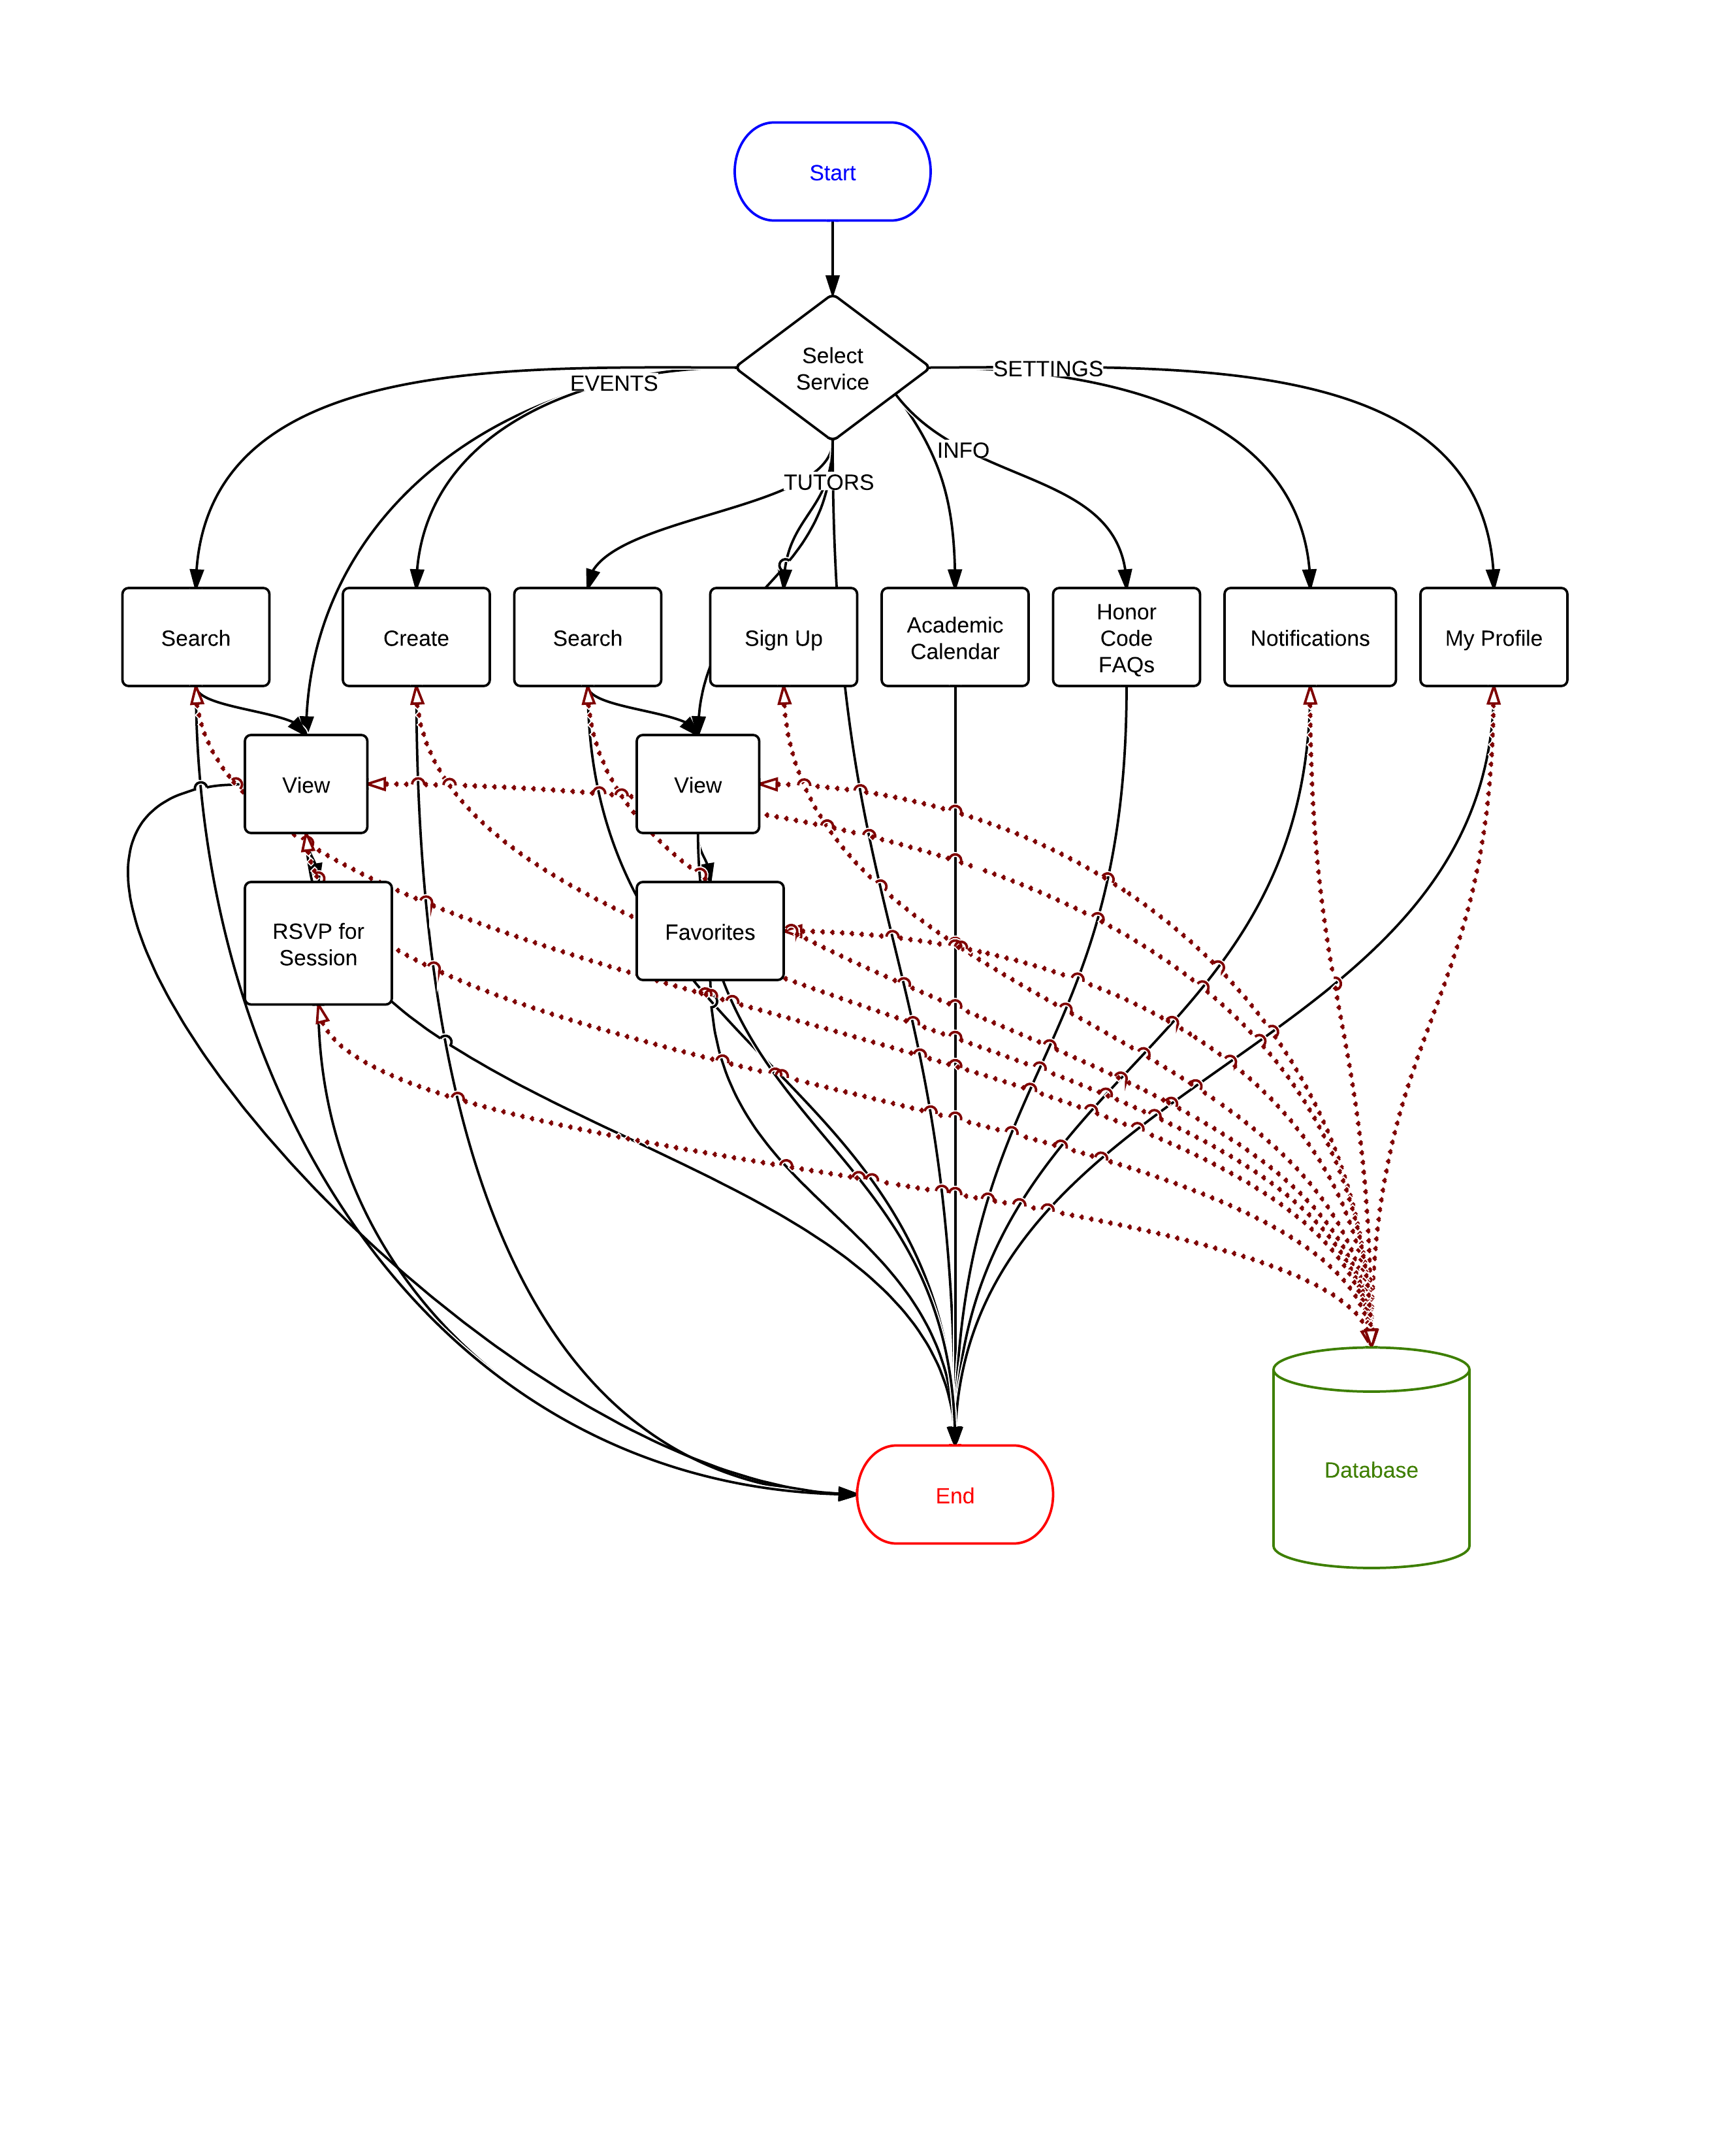Process Flow Diagram